**Exercise**

1. As a programmer, you are required to create a program that takes the first and last name from

a user. The program then combines both the inputs taken and prints the string backwards.

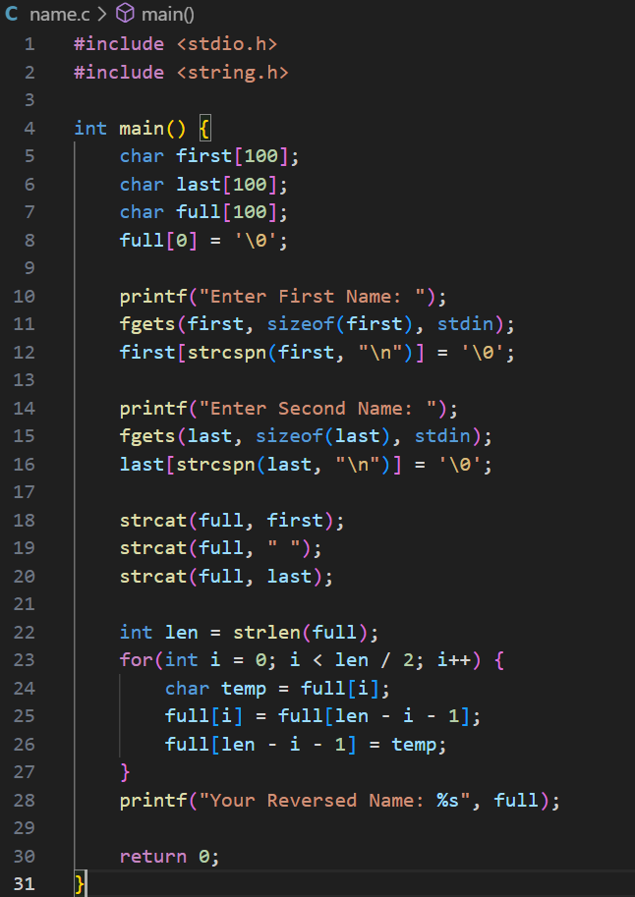

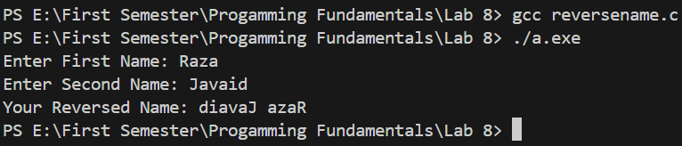

2. Each student is required to find out the maximum frequency of characters occurring in them,

name and the courses offered in Fall 2021. To find it, the student enters their name, courses

offered and the program finds the maximum occurrences of a character in the name and course.

Course names should be used like Programming Fundamentals, Applied Physics, Pakistan Studies

and so on.

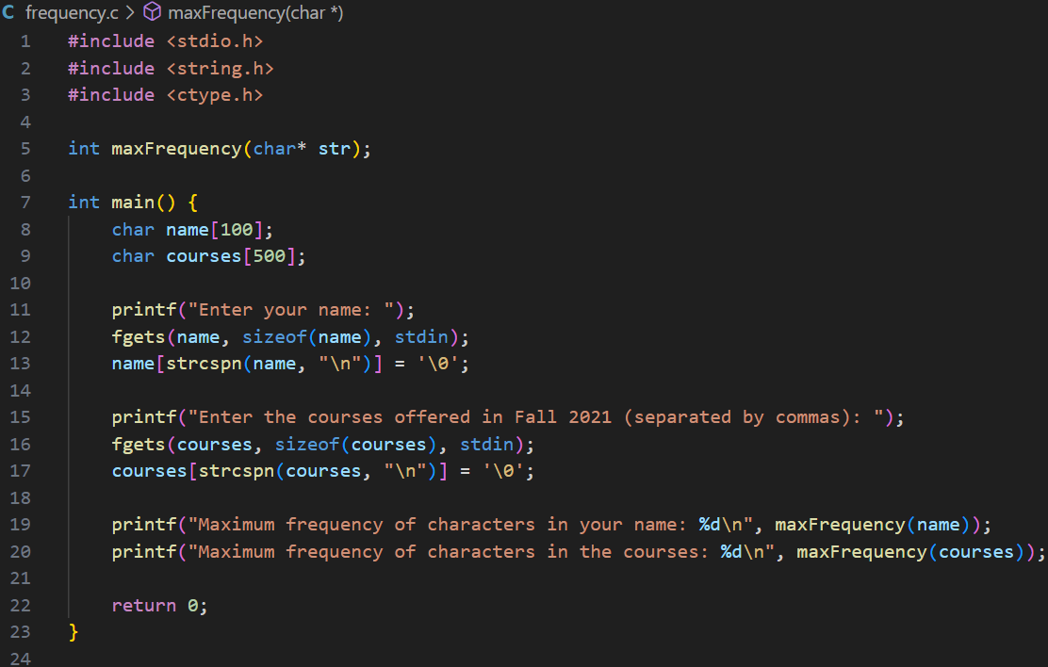

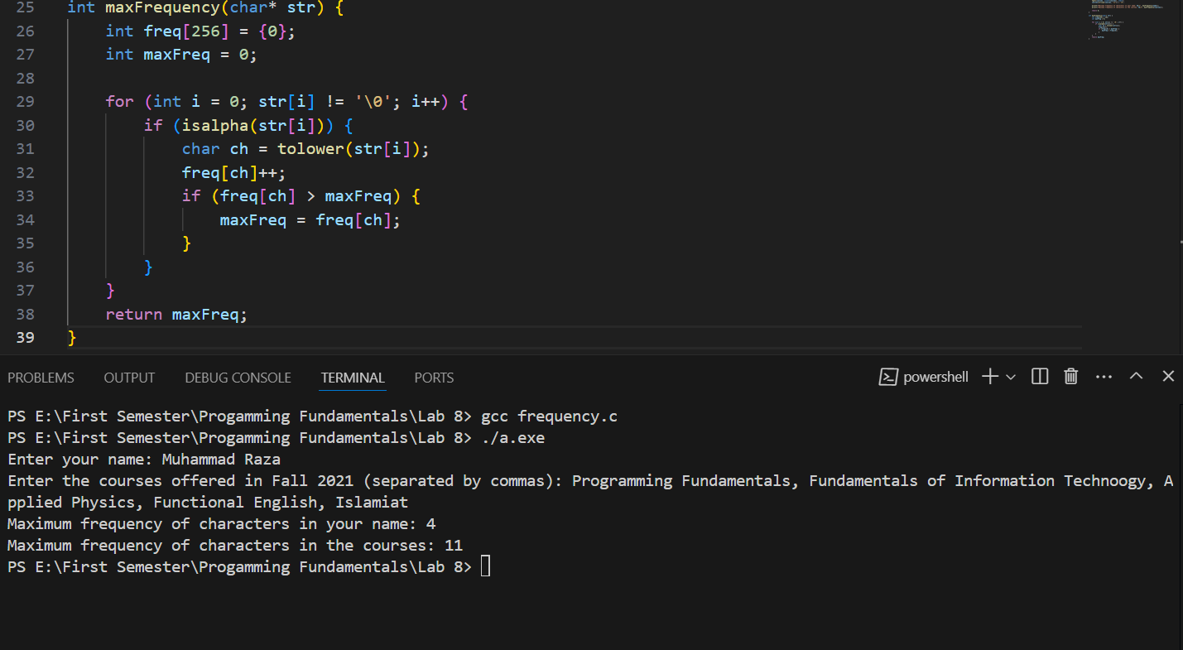

3. Students are grouped in two to complete a lab task. Each student is required to enter a string

of their own choice as an input to the program. The program will then display as a result

whether both the strings are equal. If the strings are not equal, the program will display which

of the string is greater.

Test cases:

Enter two strings that are same.

Enter two different strings.

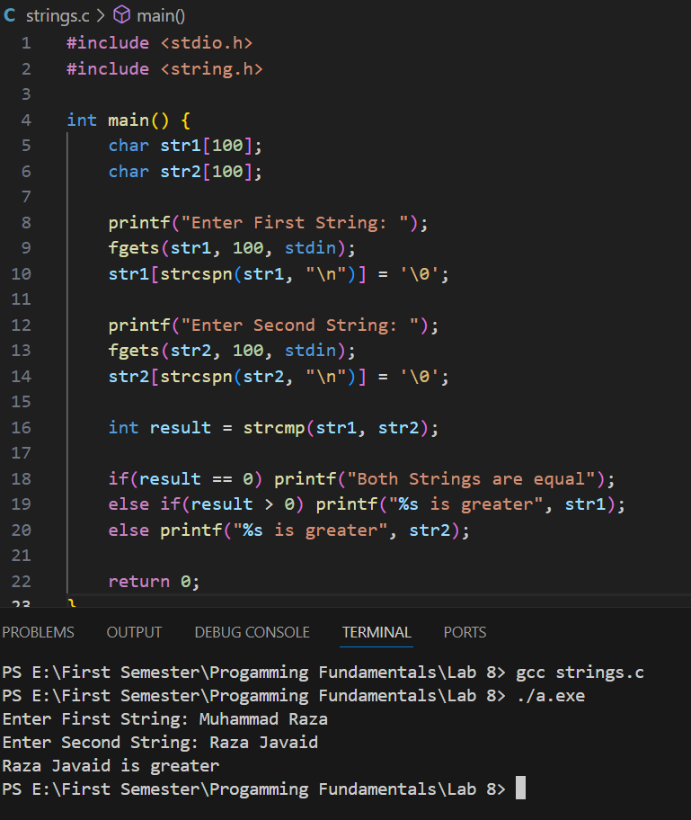

4. Write down the output of the following program.

